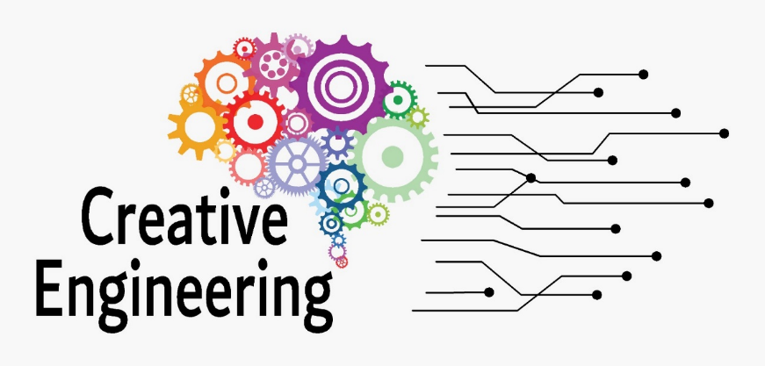
Analysis report of a comparison of current curriculums
Summary
2022-1-SK01-KA220-HED-000090102

Used Abbreviations

EC | European Commission
EU | European Union
PR | Project Results
LP | Lead Partner
HED | Higher Education
CEDE | CREATIVE ENGINEERING

Comparation of Level of study, Key words, sector
The current document it’ a template for analysis report of a comparison of current curriculums of engineering faculties with a focus on creative engineering.

Report Objectives and Expected Results
The Covid-19 Pandemic has caused all educational processes to be transferred to digital media at an unexpected speed.
Higher education institutions have also had to keep up with this situation and most of their education is carried out on eLearning platforms in digital environments. Considering that today's engineering faculty courses are also conducted online, it is necessary to prepare and give the creativity course in digital environments.
The expected result of this report is to provide a comparative report examining the handling of creativity in engineering faculties at different universities.

ITALY
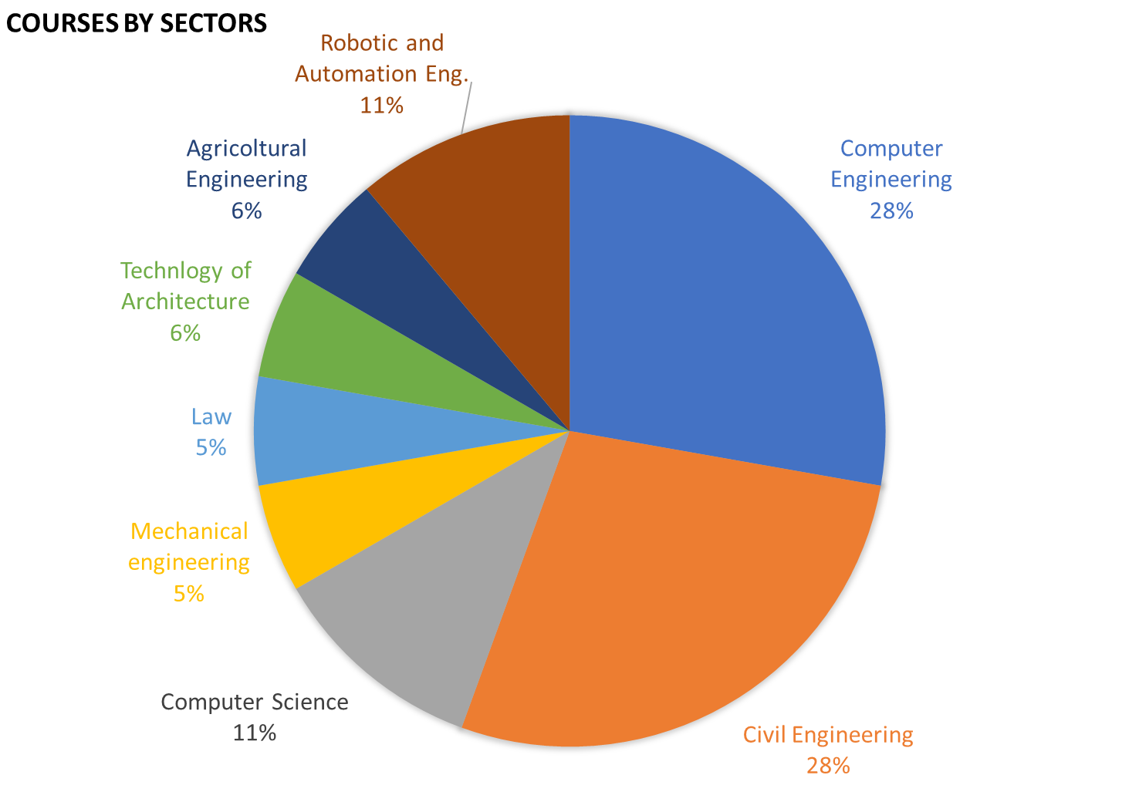
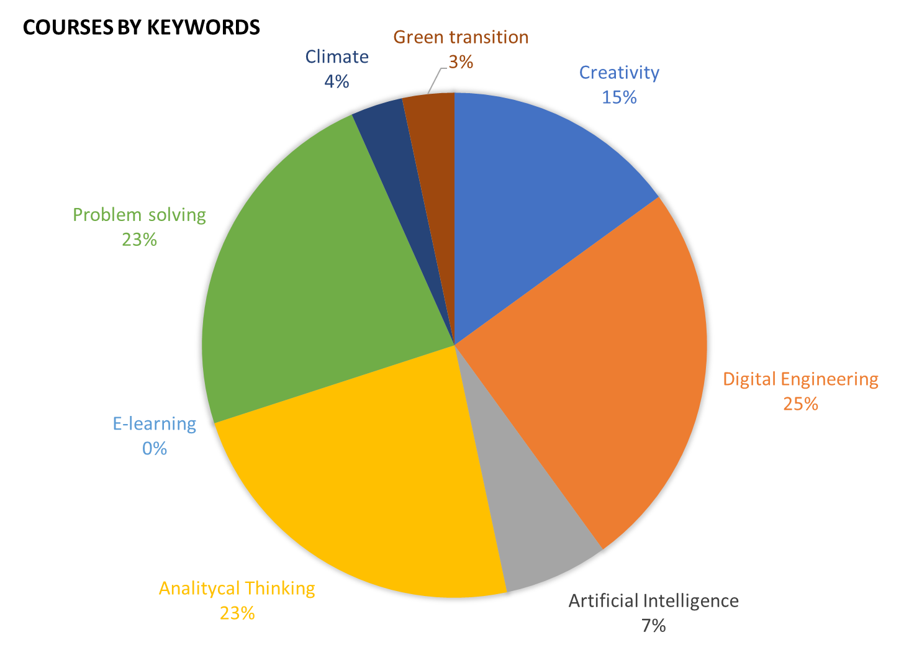

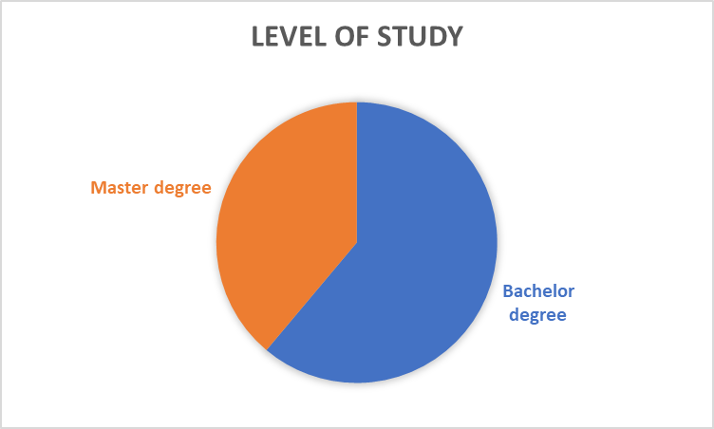
In Italy, the most presented sectors are:
- civil engineering
- computer engineering.
The dominant keywords are:
- Digital engineering
- Analytical thinking.
There are more bachelor's courses than master's courses.

GREECE
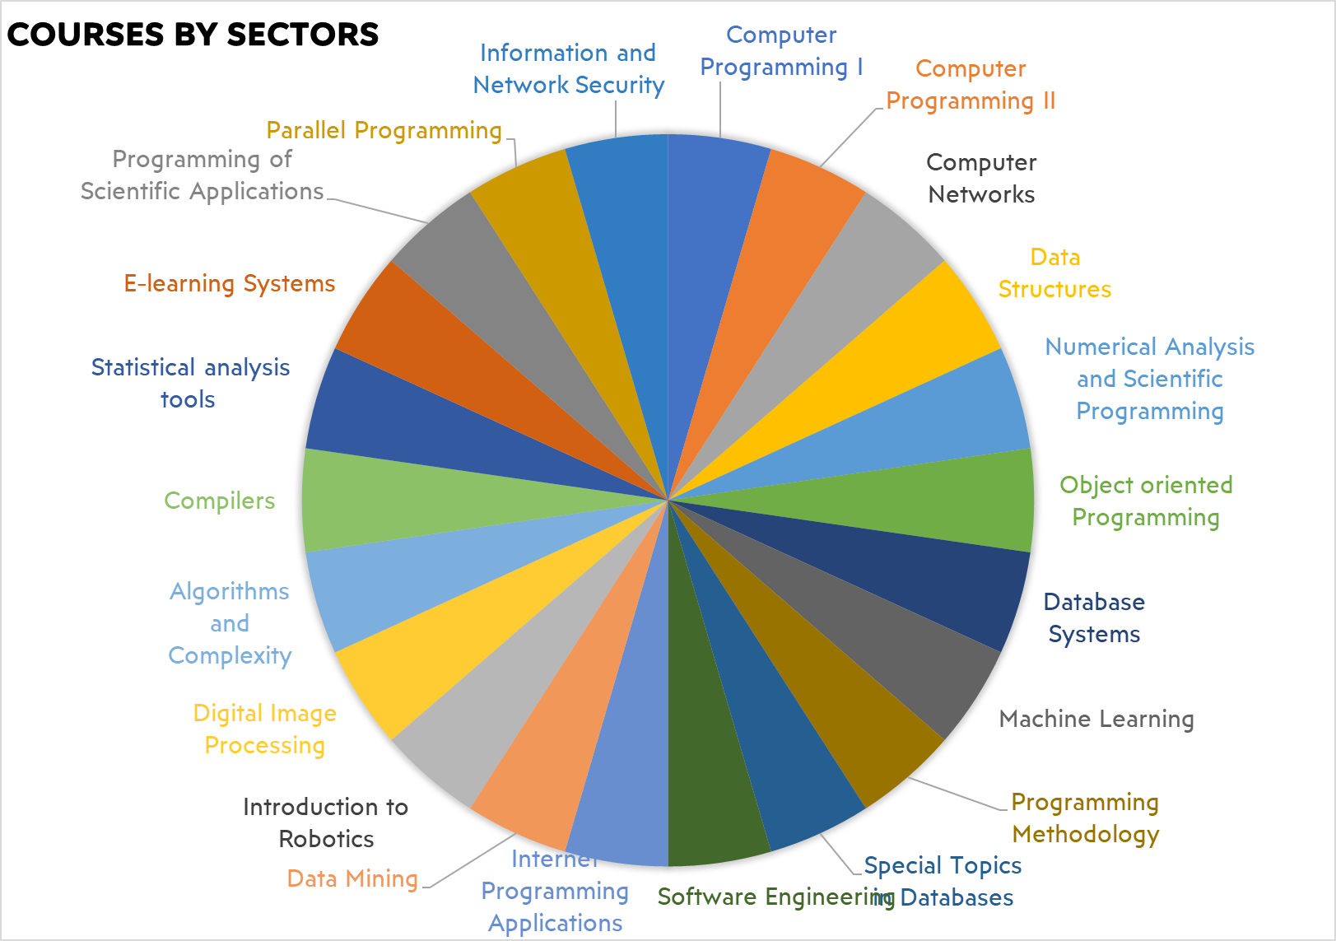
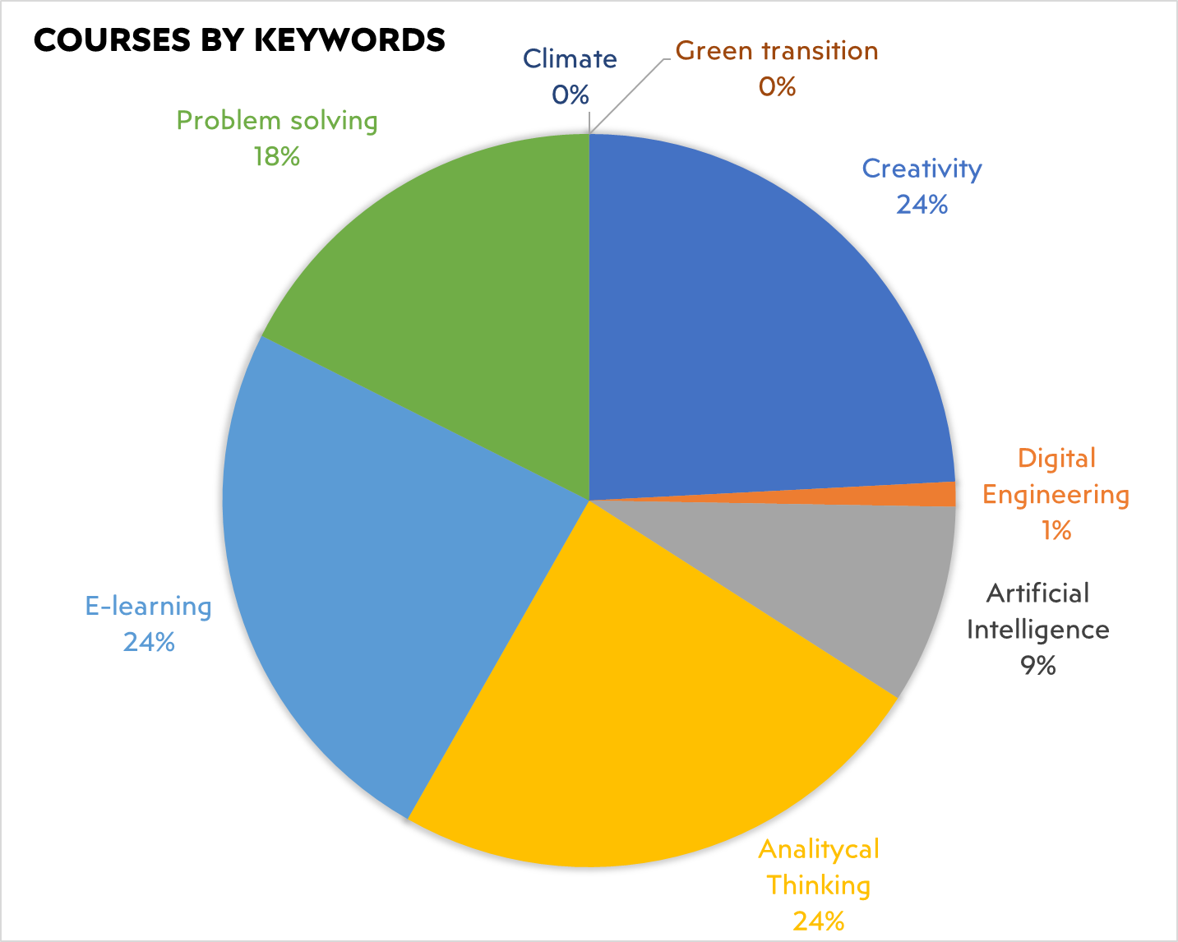

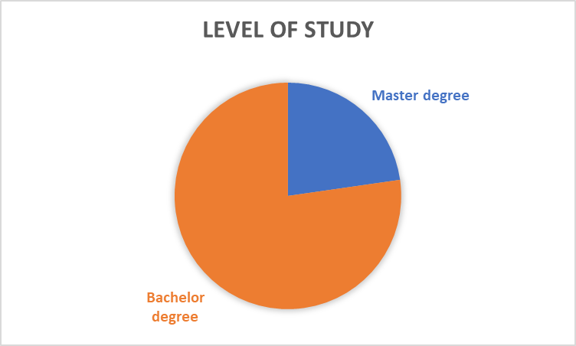
In Greece there are 22 sectors of courses. The dominant keywords are:
- e-learning
- Analytical thinking.
There are more bachelor's courses than master's courses.

SLOVAKIA
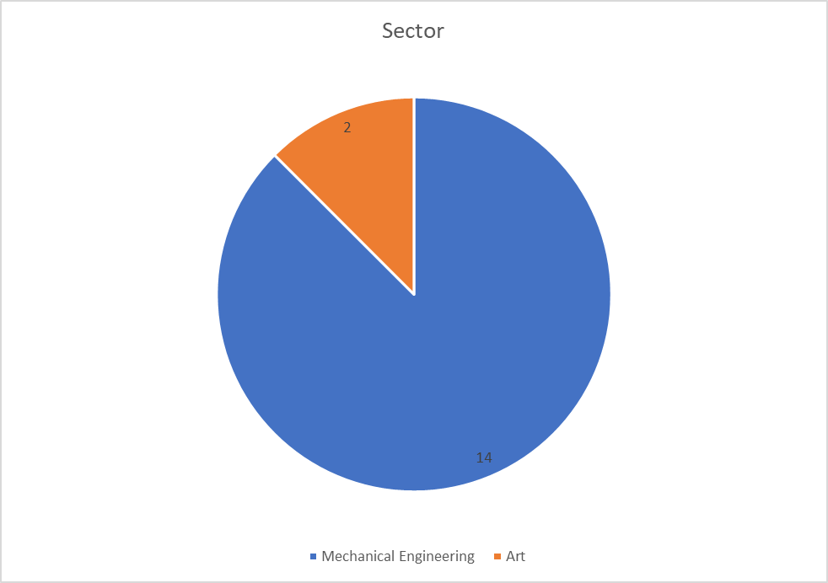
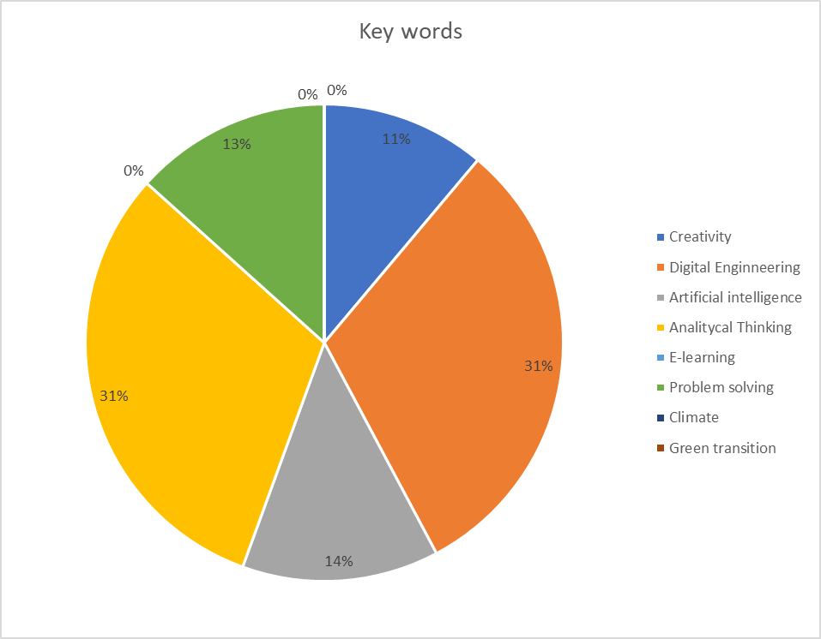
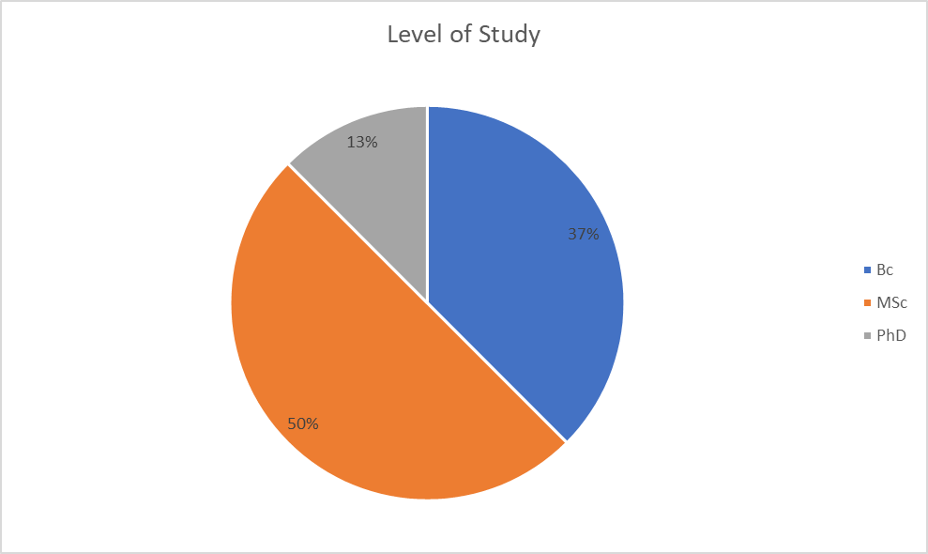
In Slovakia the most presented sector is Mechanical engineering, and the dominant keywords are:
- Digital engineering
- Analytical thinking.
There are more master's degree courses than bachelor's courses.

SPAIN
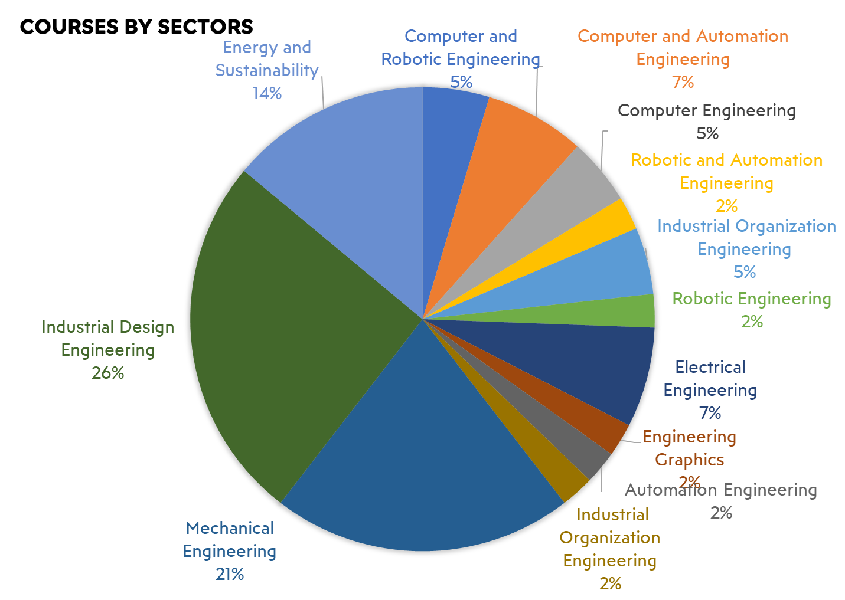
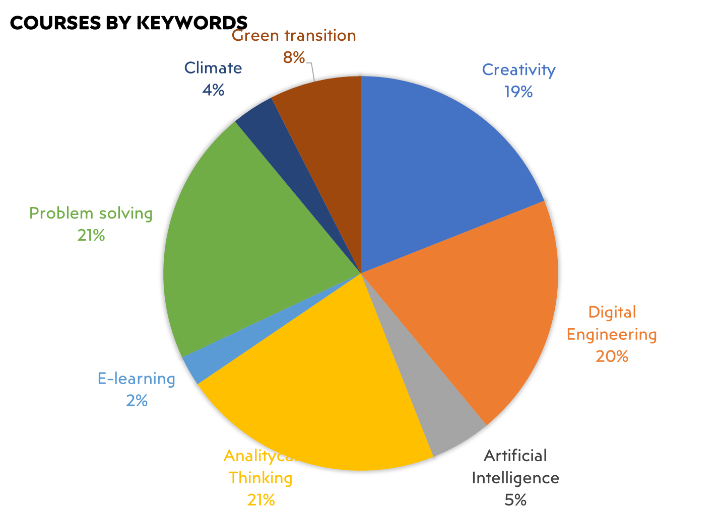

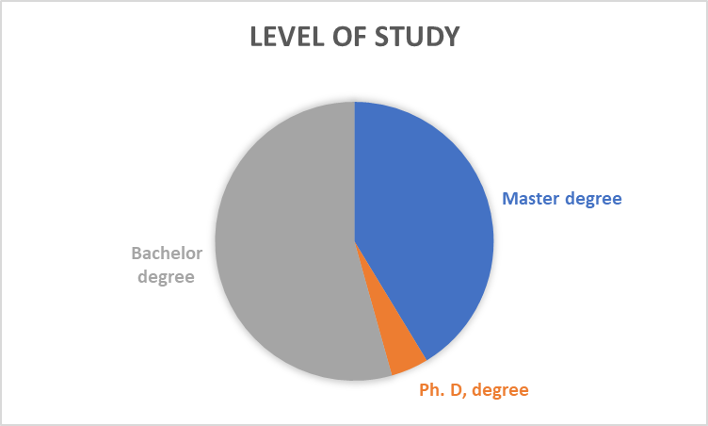

In Spain, the most presented sector are:
- Industrial design engineering
- Energy and sustainability.
The dominant keywords are:
- Problem solving,
- Digital Engineering,
- Analytical thinking.
There are more bachelor's courses than master's courses.

TURKEY
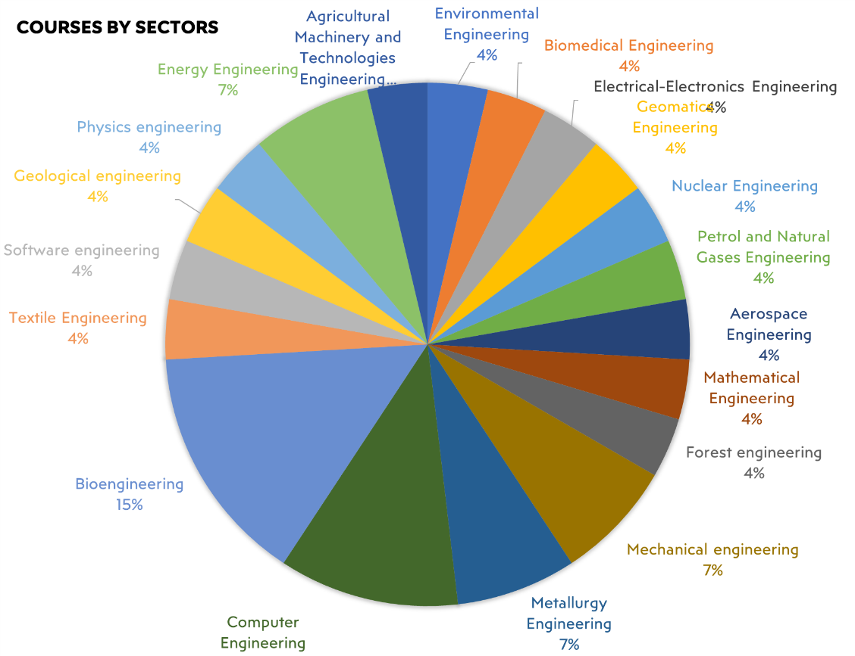

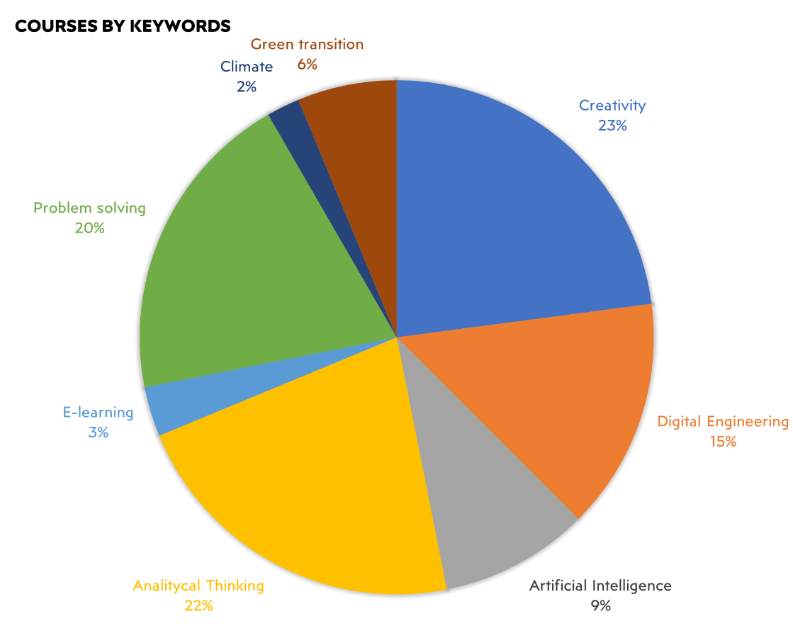
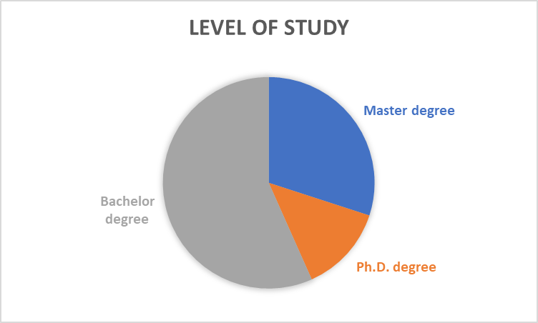
In Turkey, the most presented sector are:
- Bioengineering,
- Computer Engineering.
Dominant keywords are:
- Creativity,
- Problem solving,
- Analytical thinking.
There are more bachelor's courses than master's courses.

CONCLUSIONS

The report includes detailed information about the curricula of the courses in which the theme of creativity is studied in the field of engineering and shows many concrete examples of creative engineering courses already available in partner countries. This report put the basis and gather the contents for the elaboration of the creativity-oriented curriculum.
Some best practices identified are:
- In Slovakia, Digital Arts: The study program connects visual arts and design with information technologies. It responds to a rapidly changing world where it is important to be able to learn new skills and where a wide range of modern digital technologies brings visual artists closer to programmers. In addition to the practical use of computers in the creative process, the program content also addresses the social dimension of the impact of digital technologies on people and the innovative means of expression that digital technologies provide to artists. The interdisciplinary nature of the program connects students with academic and business subjects in the fields of art, computer science or data science, but also in the fields of humanities, social sciences and history. In addition to standard forms, studio creation focuses, for example, on interactive digital works, virtual reality and augmented reality (AR/VR) experiments, data visualizations, video games, interactive installations involving the visitor and others.
- In Turkey, Special Topics in Application of Nuclear Technique: The practices of this course are explored in depth starting from the 2nd year of the training course, where each semester, students are required to attend a different project path and are encouraged to take an active part in research. Through the use of computer codes such as FLUENT, ANSYS, MCNP and ORIGEN; analyzes and simulations of engineering systems are performed and solutions to current problems related to nuclear technology are sought. Technological problems of energy production by fission receive primary emphasis.
- In Italy, Agri-Tech: Technologies for a sustainable agriculture: The course focuses on advanced technological solutions in the agricultural field aimed at integrating a sustainable use of natural resources, a reduced impact on environmental sectors and the promotion of circular approaches, maximizing agricultural production, also in line with the EU Farm to Fork strategy and common agricultural policy. The course will introduce students to the key resources and needs of agriculture, identifying critical aspects with potential negative environmental effects (e.g. water use, agrochemical contamination, soil depletion, etc.). The most advanced technological solutions available to overcome these critical issues will be presented. The advantage of the course concerns the organization of practical activities (including soil characterization and field measurement of the main soil parameters, installation of sensors and data uploading, drone monitoring) in the field, with which students will be able to:
  - Develop an interdisciplinary approach to critical issues and technological solutions in agriculture;
  - Develop key capabilities in the systemic design of approaches and technologies for monitoring and optimizing agricultural production;
  - Identify and contextualise key issues associated with sustainable use of resources;
  - Identify, compare and select the most effective technological solutions for reducing the impacts of agricultural production.
- In Spain, Master’s degree in automatic control and robotics: The program lasts two academic years and includes a master's thesis and training in an industrial or research environment. It is divided into compulsory and free-optional subjects. The compulsory subjects provide students with multidisciplinary training in automatic control systems, robotics and robotic systems in various environments; computer vision; information technology and communication in the processing elements; and scientific and technological instruments. In free-choice subjects, students complete their education in the areas of their interest. This master trains graduates who have achieved a high level of excellence in the analysis, management and optimization of process control and robotics, industrial engineering and residential, social and service environments, activities essential for social progress, productivity economy and quality of life.

