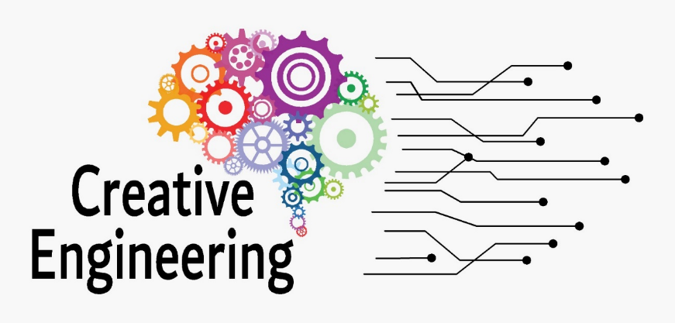

Curriculum “Communication for Creative Engineering”
2022-1-SK01-KA220-HED-000090102

CONTENTS
1 Communication for Creative Engineering 3
1.1 Competence Unit 3
1.2 Learning Outcomes 3
1.3 Evaluation Criteria 5
1.4 Pedagogical Methods 6
2 Recommended or required reading: 9
3 Detailed content for the course 10

Communication for Creative Engineering
Core Unit Title: Creative Engineering
Training Module Title: Communication for Creative Engineering

Competence Unit
The aim of these competence units and learning outcomes is to equip students with the necessary skills and knowledge to excel in communication in a creative engineering context, to support their ability to effectively communicate technical ideas, to work collaboratively in teams and to bridge the gap between engineering concepts and the wider environment. audience.
Oral communication: The student will be able to express his ideas, concepts and technical information clearly and effectively through spoken language.
Written communication: The student will gain knowledge on how to present technical and creative ideas through written documents, reports and presentations.
Visual communication: The student acquires the skills necessary to use visual aids, graphics and multimedia tools for visual communication.
Interpersonal communication: The student will acquire the skills to effectively use collaborative communication within engineering teams, learn to actively listen and resolve conflicts.
Technical communication: The student will learn to communicate the terminology used in engineering in such a way as to be able to present complex technical information in a form suitable for laymen.

Learning Outcomes
After successfully completing the subject "Communication for Creative Engineering", students are able to demonstrate the following competencies, skills and knowledge:

Competencies
A – Specific Competences (related to the core unit)
Code | Competence Description
A1 | Ability to present technical ideas clearly and persuasively in oral and written form.
A2 | Ability to structure information logically and adjust the message to the audience (professional, general public, team).
A3 | Capacity to use visual communication tools (e.g., infographics, diagrams) in technical presentations.
A4 | Ability to engage in constructive feedback, active listening, and professional dialogue.
A5 | Capacity to lead or contribute effectively to technical meetings and project communication.
B – Basic Engineering Competences
Code | Competence Description
B1 | Understand and apply key principles of engineering communication.
B2 | Use technical language appropriately in professional and academic settings.
B3 | Draft, edit, and revise documents such as reports, emails, abstracts, and executive summaries.
B4 | Demonstrate understanding of intercultural and multilingual aspects of engineering communication.
B5 | Apply ethical and professional standards when communicating in teams and with clients.
B6 | Understand the importance of clear communication in the context of engineering risk and safety.
B7 | Identify communication barriers and propose appropriate strategies to overcome them.
B8 | Collaborate in interdisciplinary teams using effective communication practices.
B9 | Select suitable digital tools for synchronous and asynchronous communication.
C – Transversal Competences
Code | Competence Description
C1 | Communicate clearly and assertively in interpersonal and group settings.
C2 | Express complex technical ideas in simplified and engaging ways.
C3 | Provide and receive constructive feedback to support mutual growth.
C4 | Reflect critically on personal communication style and adapt as needed.
C5 | Contribute to inclusive and respectful communication in diverse teams.

Knowledge
By the end of the module, students will have gained an understanding of:
- Fundamental principles of communication theory relevant to engineering contexts (e.g., sender-receiver model, barriers, noise)
- Structure and types of professional communication (emails, summaries, technical reports)
- Key elements of audience-centered communication
- Verbal vs. non-verbal communication and their impact in technical presentations
- The role of communication in teamwork, leadership, and innovation processes
- Tools and techniques for visual communication (e.g., infographics, sketches)
- Intercultural communication in multinational engineering environments
- The importance of clarity, empathy, and ethics in engineering communication

Skills
Skill | Linked Competences
Structure and deliver effective oral presentations on technical topics | A1, A2, A3, C1
Write concise and purposeful technical documents (e.g., emails, abstracts) | A1, B3, B5
Use appropriate tone, style, and language for different audiences | A2, B2, C2
Create and interpret visual communication elements | A3, B9
Collaborate within teams and communicate ideas clearly during project work | A5, B8, C1, C5
Provide and receive constructive feedback in peer/professional settings | A4, C3
Adapt communication style based on context, culture, and role | B4, C2, C4
Reflect critically on their own communication strengths and development areas | A4, B7, C4, C5

Evaluation Criteria
Assessment in this module focuses on how well students can apply communication principles in various engineering contexts, both written and oral, individual and group-based. The evaluation also encourages self-reflection and peer feedback as part of a continuous learning process.
- Total: 100%
The evaluation is divided into three complementary components:

Continuous Assessment – 20%
Ongoing engagement in class activities and group work.
Includes:
- Active participation in discussions and simulations
- Completion of preparatory tasks and micro-assignments
- Peer-to-peer feedback tasks
Assessed Competences: A4, B1, B8, C1, C3
Assessment tools: Observation rubric, participation log

Group Project – 30%
Small teams (3–5 students) prepare and deliver a technical mini-presentation, demonstrating their ability to structure, visualize, and communicate an engineering concept to a mixed audience.
Includes:
- Presentation with visual aids (e.g., infographic, prototype sketch)
- Clarity, logic, persuasiveness of message
- Team collaboration and feedback integration
Assessed Competences: A1, A2, A3, B2, B5, B9, C2, C5
Assessment tools: Presentation evaluation rubric, peer feedback form

Final Individual Output – 50%
Each student submits an individual communication portfolio, including:
- 1 written document (e.g., executive summary or technical email)
- 1 visual item (e.g., infographic, concept sketch)
- 1 reflection (written or recorded) on personal communication strengths and areas for improvement
Includes:
- Demonstration of professional written communication
- Integration of visual and verbal elements
- Self-reflection based on feedback received
Assessed Competences: A1, A2, A4, B3, B4, B6, C4
Assessment tools: Scoring rubric, self-assessment questionnaire
Additional Notes:
- All assessment instruments are aligned with the CEDE Evaluation Toolkit.
- Rubrics ensure transparency and comparability across evaluators.
- Optional bonus points (up to +5%) may be awarded for outstanding creativity or outreach impact.

Pedagogical Methods
The Communication for Creative Engineering module employs active, learner-centered teaching methods designed to develop both technical and interpersonal communication skills. These pedagogical approaches promote experiential learning, collaboration, and critical reflection, aligning with the constructivist principles of the CEDE Learning Model.

Interactive Lectures
Short inputs provide theoretical background (e.g., communication models, feedback techniques) supported by real-life examples and visual demonstrations. These are interspersed with open questions, brainstorming, and polls to stimulate student engagement.
Used for: introducing key concepts, activating prior knowledge

Role-Play and Simulation
Students simulate communication scenarios, such as team briefings, product pitches, or conflict resolution. These activities allow them to practice verbal, non-verbal, and intercultural communication in a safe, supportive environment.
Used for: developing presentation skills, teamwork dynamics, managing feedback
Example: “Present your concept to a skeptical manager from another department.”

Peer Teaching and Feedback
Students are encouraged to teach small segments (e.g., present an infographic or lead a discussion) and provide structured peer feedback using rubrics. This develops analytical thinking and empathy in communication.
Used for: reinforcing understanding, feedback literacy

Visual Thinking and Communication Tools
Students experiment with visual formats (e.g., infographics, sketches, diagrams) to present technical ideas clearly. They learn principles of visual hierarchy, simplification, and alignment to communicate effectively beyond words.
Used for: digital literacy, message clarity
Example tools: Canva, Miro, PowerPoint SmartArt

Reflective Practice
Journaling, self-assessment checklists, and guided reflection questions are used to help students monitor their growth, identify challenges, and internalize feedback.
Used for: developing metacognition, self-awareness
Example prompt: “What was your biggest communication breakthrough this week?”

Collaborative Problem Solving
Students are placed in interdisciplinary groups to solve realistic communication challenges—e.g., drafting a team strategy for a failed prototype presentation or redesigning an onboarding email for new engineers.
Used for: integrating soft and technical skills, fostering adaptability

Digital and Hybrid Learning Tools
To support blended or remote delivery, instructors can use platforms such as:
- Padlet/Miro – visual idea mapping
- Mentimeter/Kahoot – quizzes and polling
- Zoom/Teams – role-play in breakout rooms
- Moodle/Google Classroom – sharing tasks and portfolios

Recommended or required reading:
- "Technical Communication" by Paul V. Anderson, this comprehensive textbook covers the fundamental principles of technical communication, making it an essential resource for engineering students.
- "The Visual Display of Quantitative Information" by Edward R. Tufte, this book explores effective data visualization, which is a critical aspect of communication in engineering and design.
- "Writing for Science" by Robert Goldbort, a practical guide that focuses on writing in scientific and technical contexts, essential for engineering students.
- "Made to Stick: Why Some Ideas Survive and Others Die" by Chip Heath and Dan Heath, this book offers insights into creating memorable and impactful messages, which is valuable for engineers looking to convey ideas effectively.
- "Slide:ology: The Art and Science of Creating Great Presentations" by Nancy Duarte, a valuable resource on creating engaging and visually compelling presentations, an essential skill for engineers.
- "Design for How People Learn" by Julie Dirksen, understanding the psychology of learning is crucial for engineers who want to communicate technical information effectively.
- "The Elements of Style" by William Strunk Jr. and E.B. White, a classic guide to improving writing style, which can benefit engineering students in their written communication.
- "Resonate: Present Visual Stories that Transform Audiences" by Nancy Duarte, focuses on the art of storytelling in presentations, helping engineers engage their audience effectively.
- "Team Geek: A Software Developer's Guide to Working Well with Others" by Ben Collins-Sussman, Brian W. Fitzpatrick, and Michael Pilato, this book offers insights into effective teamwork and collaboration, which are essential for engineers.
- "Made to Stick: Why Some Ideas Survive and Others Die" by Chip Heath and Dan Heath, offers valuable insights into crafting messages and presentations that are memorable and impactful, a critical skill for engineering communication.

Detailed content for the course
Language of the course:
Names of the lectures:
Teaching hours: 30 hours
Mode of delivery: distance, online
Notes:

- Introduction to Communication Skills (3h)
- Communication Skills
- Effective Written Communication
- Effective Verbal Communication
- Interpersonal Communication and Collaboration
- Communication in Design Thinking and Innovation
5.2. Public Speaking and Presentations (3h)
- Ethical and Responsible Communication
- Effective use of digital communication tools
- Communicating business ideas and value propositions
5.3. Case Studies and Practical Exercises (3h)
- Role-playing exercises for various communication scenarios
5.4. Bibliography

